**Source Analysis Exercise II:**

**Source 1**

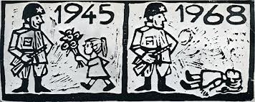

**An anti-occupation poster, Czechoslovakia.**

**Source 2**

**THE PRAGUE SPRING**

Dubcek started the reformative Action Programme, ‘Prague Spring’ in April 1968. The reforms included:

* -Abolition of strict censorship
* -Giving minor parties the chance to join the government, which was dominated by the Communist Party.
* -Offering equal rights to the Slovaks.
* -Cultural freedom

The Prague Spring was a Communist-friendly program, aimed for the establishment of ‘communism with a human face.’ Alexander Dubcek commented:  
  
-"I can only say, think of me what you will, I have worked for thirty years in the Party, and my whole family has devoted everything to the affairs of the Party, the affairs of socialism." ………"I responded that we needed a private sector to improve the market situation and make peoples’ lives easier."………"The program proclaimed a return to freedom of the press and proposed the adoption of a press law that would clearly exclude prepublication censorship."………"We shall have to remove everything that strangles artistic and scientific creativeness."

**Source 3**

The Soviet Government and all the Soviet people deeply regret that the development of events in Hungary has led to bloodshed. On the request of the Hungarian People's Government the Soviet Government consented to the entry into Budapest of the Soviet Army units to assist the Hungarian People's Army and the Hungarian authorities to establish order in the town. Believing that the further presence of Soviet Army units in Hungary can serve as a cause for even greater deterioration of the situation, the Soviet Government has given instructions to its military command to withdraw the Soviet Army units from Budapest as soon as this is recognized as necessary by the Hungarian Government. At the same time, the Soviet Government is ready to enter into relevant negotiations with the Government of the Hungarian People's Republic and other participants of the Warsaw Treaty on the question of the presence of Soviet troops on the territory of Hungary. . . .The Soviet Government expresses confidence that the peoples of the socialist countries will not permit foreign and internal reactionary forces to undermine the basis of the people's democratic regimes, won and consolidated by the heroic struggle and toil of the workers, peasants, and intelligentsia of each country. They will make all efforts to remove all obstacles that lie in the path of further strengthening the democratic basis of the independence and sovereignty of their countries, to develop further the socialist basis of each country, its economy and culture, for the sake of the constant growth of the material welfare and the cultural level of all the workers. They will consolidate the fraternal unity and mutual assistance of the socialist countries for the strengthening of the great cause of peace and socialism.

**Friendship and Co-operation Between the Soviet Union and Other Socialist States, October 30, 1956.**  **Reprinted from *The Department of State Bulletin, XXXV,* No. 907 (November 12, 1956), pp. 745-747.**

**Source 4**

|  |  |
| --- | --- |
|  |  |

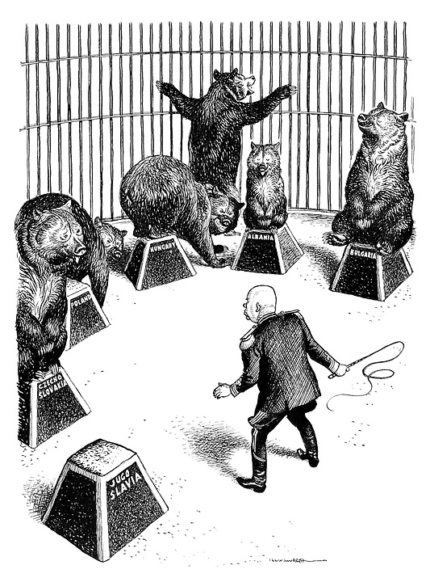

**Punch Magazine, 1956. Nikita Khrushchev as circus trainer tries to impose order on his bears as the disobedient Yugoslav bear runs away and tries to escape the cage.**

**Question 1**

1. Explain the historical context of **Source 1**. Include the relevant events, people and ideas depicted or represented in the source. *(3 marks)*

|  |  |
| --- | --- |
| **Description** | **Marks** |
| Identifies the focus of the source | 1 |
| Outlines the causes or event that led to the focus of the source | 1 |
| Provides details of the focus of the source, events/people/ideas/dates/places | 1 |
| **Total** | **3** |
| **Note:** This question is concerned with the historical context in which the source is located. Answers should focus on what is in the source and provide the big ‘picture’ for that source. |  |

**See next page**

**(b)** Compare and contrast the purpose of **Sources 1** and **2.** (6 marks)

|  |  |
| --- | --- |
| **Description** | **Marks** |
| Identifies the purpose of the Source 1 | 1 |
| Identifies the purpose of the Source 2 | 1 |
| Identifies elements of comparison between the two sources | 1-2 |
| Identifies elements of contrast between the two sources | 1-2 |
| **Total** | **6** |
| **Note: This question focuses on the reasons for the construction of the sources, and what they aim to achieve. Answers should identify the issue/event/subject of each source; identify the message of the sources; identify the likely purpose for which the source was constructed (or, in the case of the photograph, how the source might have been used, which might produce variations in student interpretation. The response should use evidence from the source to support the response. Lastly, the response should** **explain how they compare (are similar) and contrast (are different) in terms of their purpose.** |  |

**(c)** Identify and explain the message/s of **Source 3**. (3 marks)

|  |  |
| --- | --- |
| **Description** | **Marks** |
| Explain the message of the source | 3 |
| Outlines the message of the source | 2 |
| Identifies an aspect of the message of the source | 1 |
| **Total** | **3** |
| **Note: Look for the message conveyed by the source. Answers should: consider all of the elements of the source: title/ author/ date/ location; identify the issue/ event/ subject; identify the representation or opinion being expressed; provide evidence from the source to support the response.** |  |

**See next page**

**d)** Identify how and discuss why **Source 3** and **4** are contestable. (6 marks)

|  |  |
| --- | --- |
| **Description** | **Marks** |
| Identifies the element/s of contestability for Sources 3 and 4 | 1–2 |
| Discusses the reasons for the contestability of Source 3 | 1–2 |
| Discusses the reasons for the contestability of Source 4 | 1–2 |
| **Total** | **6** |
| Note: The concept of contestability requires a discussion of conflicting historical interpretations represented in source material, specifically why they are different and open to debate. Answers should demonstrate an understanding of what can make a source contestable, whether it provides a certain interpretation of events for which other interpretations exist; or whether the source/s can be disputed as historical evidence. Identify in each source the argument/s, biases, motives or perspectives that can be disputed. Stronger candidates may discuss the nature of the contestability, perhaps by referring to alternative arguments or viewpoints on the interpretations presented by the sources, or by making comparisons between the two sources. |  |

**See next page**

**(e)** Using your knowledge of the whole period of study, evaluate the importance of the

idea of foreign policy represented in the four sources. (7 marks)

|  |  |
| --- | --- |
| **Description** | **Marks** |
| Identification of the themes/ ideas/ events | 1 |
| Placement of the themes/ ideas/ events with the themes/ ideas/ events of the broader historical context of the time. Students should be able to demonstrate a breadth and depth of the time period. | 1–2 |
| Evaluation of the themes/ ideas/ events in relation to those of the broader context. | 1–2 |
| Compare and/or contrast with what is in the sources with the other themes/ ideas/ events within the time period. | 1–2 |
| **Total** | **7** |
| Note: This question does not require reiteration of the messages in the sources.  Evaluate the importance of the theme/idea/event in relation to how they are represented in the sources; relates to the other themes/ideas/events of the whole period.  Answers should identify the themes/ideas/events in the sources; evaluate the importance of what is shown in the sources by using evidence from the sources and the whole historical period; refer to the long-term and/or short-term effects of the theme/idea/event; refer to elements of continuity and/or change evident in the theme/idea/event; demonstrate a depth and breadth of knowledge for the whole time period. |  |

_______________________________________________________________________

__________________

________________________________________

**END OF SECTION**